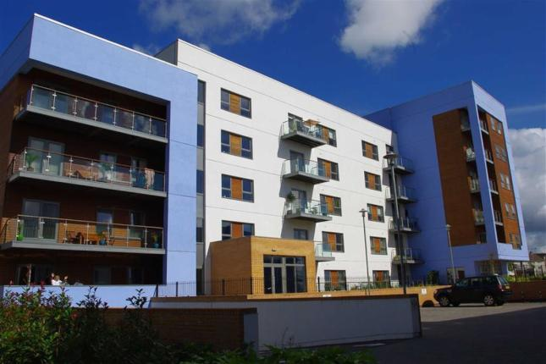

**Mariners Court Apartment Complex – 80 Apartments**

**Based at the heart of Swansea’s innovative SA1 area, this low energy sustainable development constructed in 2007 comprises of 80 fully serviced apartments and a ground floor cafe overlooking the Maritime Quarter. The 4, 5 and 6 storey block have a timber framed structure with single ply membrane mono pitched roofs, Scandinavian composite aluminium/pine windows and walk on steel and glass balconies Seven Oaks Timber Frame provided the timber frame superstructure, floors and flat roof structure for all 3 adjoining apartment blocks on this project.**

**Client – Jistcourt South Wales Ltd**

**Architect – Holder Mathias**